**Project Title: Decoding emotions through sentiment analysis**

**of social media conversations**

**PROBLEM STATEMENT**

Social media platforms have transformed how individuals communicate and express emotions. These platforms, such as Twitter, Facebook, Reddit, and Instagram, are filled with rich, real-time data generated by users sharing opinions, thoughts, and experiences. Analyzing this content can yield valuable insights into human behavior, social trends, and emotional well-being.

This project focuses on understanding and decoding the emotional context embedded in social media conversations using sentiment analysis and machine learning. The central question we aim to answer is:

How effectively can machine learning algorithms detect and classify human emotions from social media text data?

The problem is cast as a multi-class classification task, where each data point is labeled with one of several emotional states: joy, sadness, anger, fear, love, and surprise.

By examining various sentiment analysis examples, we can identify common trends and patterns that reflect consumer behavior. Whether it’s monitoring social media comments or interpreting reviews, these examples provide clear insights into how customers feel about a brand. Understanding these sentiments is vital for any business wanting to adapt and thrive in a competitive market.

Consider how customer feedback varies across social media platforms. For instance, a restaurant's social media page may receive praise for its service, while a product review might reveal dissatisfaction with the same company's customer support. Such sentiment analysis examples highlight the significance of language in conveying feelings.

When it comes to deciphering emotions online, cutting-edge tools stand at the forefront of social media sentiment analysis. **Natural Language Processing (NLP)** tools like **VADER**, **TextBlob**, and **SentiStrength** have revolutionized how brands understand audience emotions. **VADER** is highly effective for analyzing sentiment in social media contexts, thanks to its capacity to handle emojis, slangs, and acronyms. On the other hand, **TextBlob** offers a simple interface for performing a variety of NLP operations, making it popular among beginners. **SentiStrength** excels at providing quick and nuanced sentiment scores in short texts, perfect for parsing through crisp tweets or Instagram captions.

**RELEVANCE AND IMPACT**

* By leveraging advanced machine learning algorithms and natural language processing (NLP) techniques, sentiment analysis can provide nuanced insights into how your audience feels about your content. Key elements often analyzed include: Polarity: Assessing whether sentiments are positive, negative, or neutral.
* The latest type of information unfairness comes from Application Programming Interface(API) ambush that works on both algorithms, information/data, and substantiate outcomes. This type of work helps us to understand how different types of information, ideas and characteristics of social media information/data can be largely considered and authenticated and in what way can be in touch arbitration mechanisms can be drafted to control pessimistic consequences. The procedure and discovery of this exertion can be thoughtful to understand various objectives of social media data/information
* Public Health: Detect early signs of mental distress in communities.
* Brand Monitoring: Gauge customer sentiment toward products or services.
* Social Research: Understand how emotions propagate through online communities.
* Crisis Management: Identify emotional surges during disasters or emergencies.

**System Requirements**

**Hardware:**

* Minimum 4 GB RAM (8 GB recommended)
* Any standard processor (Intel i3/i5 or AMD equivalent)

**Software:**

* Python 3.10+
* Libraries: pandas, numpy, matplotlib, seaborn, scikit-learn, nltk, gradio
* IDE: Google Colab / Jupyter Notebook

**PROJECT OBJECTIVES**

The main objective of a sentiment analysis project is to determine the emotional tone or sentiment expressed in text data, whether it's positive, negative, or neutral. This analysis helps understand customer opinions, analyze public sentiment, identify trends, and assess financial news. It can also be used to improve product offerings by identifying what works and what doesn't, based on customer feedback.

This project aims to understand and analyze public opinion on social media by decoding emotions expressed in online conversations. The project will use sentiment analysis, a technique that uses natural language processing and machine learning to identify the sentiment expressed in text, whether positive, negative, or neutral. This project will also involve data collection from social media platforms, data preprocessing, model training, and evaluation to assess the accuracy of sentiment analysis.

Sentiment analysis can be approached in various ways, depending on the complexity of the task and the available resources. Here are three common methods:

**1. Rule-Based Sentiment Analysis:** This method relies on predefined rules and dictionaries to assign sentiment scores to words and phrases. For example, the word “happy” might be associated with a positive sentiment, while “angry” might be associated with a negative one. This approach is relatively simple but can be limited by its inability to capture nuances and context.

**2. Machine Learning-Based Sentiment Analysis:** Machine learning models, including deep learning techniques, are used to build sentiment classifiers. These models are trained on labeled datasets, allowing them to learn patterns and relationships between words and sentiments. They can handle more complex tasks and are capable of recognizing contextual cues.

**3. Hybrid Approaches:** Some sentiment analysis systems combine rule-based and machine learning-based methods to improve accuracy. These hybrid approaches leverage the strengths of both techniques to achieve a balance between precision and recall.

* To construct a high-quality dataset from raw social media text.
* To clean and preprocess unstructured text effectively.
* To extract meaningful features using NLP and statistical methods.
* To experiment with and compare multiple machine learning models.
* To evaluate the models with appropriate performance metrics.
* To visualize emotional trends and model behavior.
* To develop a robust, scalable pipeline that can be adapted to other domains.

**FLOWCHART OF THE PROJECT WORKFLOW**

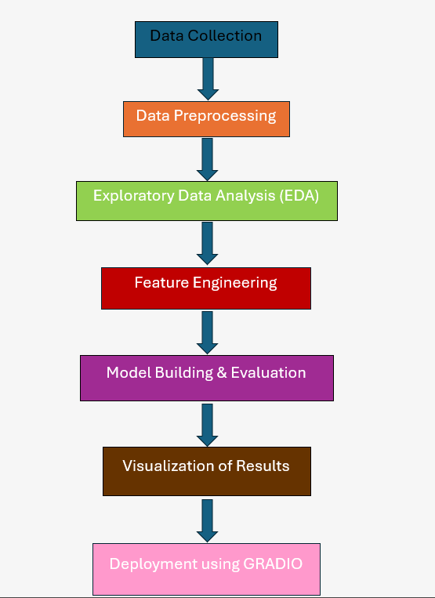

**DATA DESCRIPTION**

* Before we can perform sentiment analysis, we need to preprocess the text data. We will lower-case the text, tokenize it into individual words, remove stopwords, and apply other text cleaning techniques. This step helps in standardizing the text data and preparing it for further analysis**.**
* This dataset consists of social media posts from various platforms. It includes both positive and negative sentiment labels, allowing for training sentiment analysis models on real-world social media data.
* Contributors meticulously examined more than 10,000 tweets gathered through diverse searches such as “ablaze,” “quarantine,” and “pandemonium.” Each tweet was annotated based on whether it referenced a disaster event, distinguishing it from jokes, movie reviews, or non-disastrous content.
* Despite its potential, sentiment analysis faces challenges such as contextual ambiguity, the usage of slang and emojis, and the complexity of handling multilingual content. These factors can sometimes lead to misinterpretation of emotions, highlighting the need for continuous improvement in the field.
* Dataset Source: Kaggle / Twitter API (based on project specifics)
* Type of Data: Text (Unstructured)
* Records & Features: [e.g., 40,000 tweets with 2 columns – Text, Emotion]
* Dataset Type: Static
* Target Variable: Emotion (categorical)
  + **Source:** Kaggle – Emotion Dataset for NLP
  + **Size:** ~40,000 samples
  + **Type:** CSV (Text and Emotion label)

**Attributes:**

* text: The social media post
* label: Emotion category (happy, sad, anger, fear, surprise)

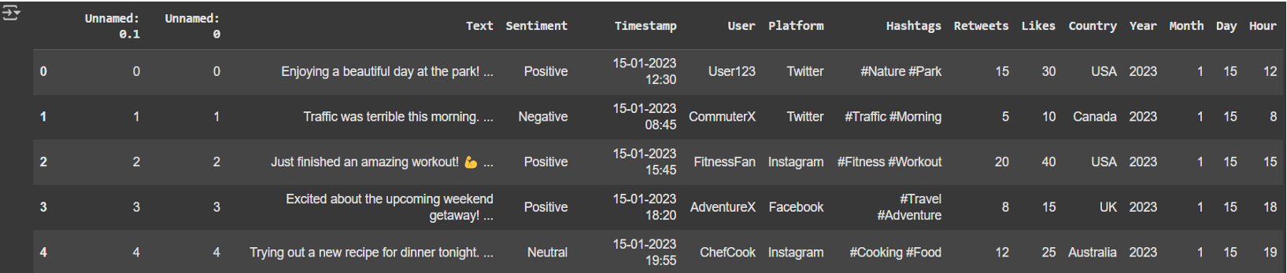

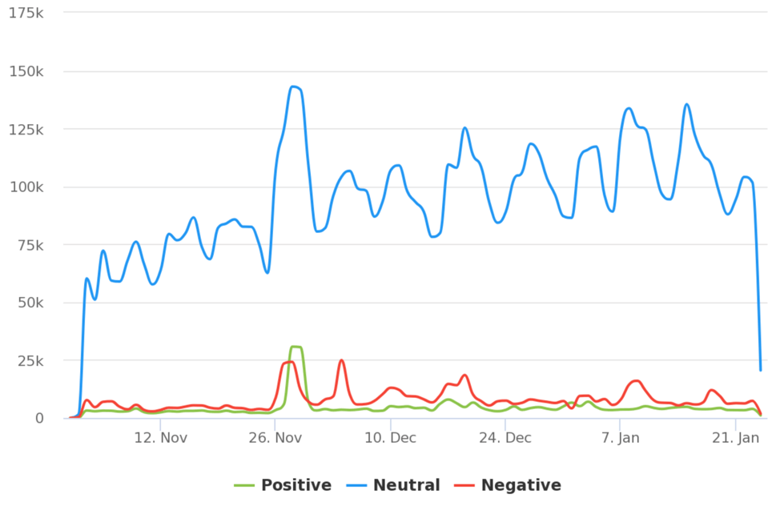

**DATA PREPROCESSING**

* Sentiment analysis on social media data involves a data processing pipeline that cleans, transforms, and prepares text for analysis, ultimately leading to the classification of sentiments (positive, negative, neutral). This process typically includes steps like cleaning, tokenization, stop word removal, and potentially feature extraction before model training and evaluation, [according to a Medium article](https://medium.com/@swayampatil7918/getting-started-with-sentiment-analysis-a-step-by-step-guide-1a16085688a7).
* Before we can perform sentiment analysis, we need to preprocess the text data. We will lower-case the text, tokenize it into individual words, remove stopwords, and apply other text cleaning techniques.
* Removed missing or null entries
* Eliminated duplicate tweet
* Lowercased text, removed punctuation, stopwords, and special characters
* Tokenized and lemmatized tex
* Encoded target labels using Label Encoding
* Transformed text into vectors using TF-IDF or Word Embeddings

• Removed special characters, links, emojis

• Lowercased all text

• Tokenized sentences

• Removed stop words

• Lemmatization using NLTK

• Split data into training and test sets (80/20)

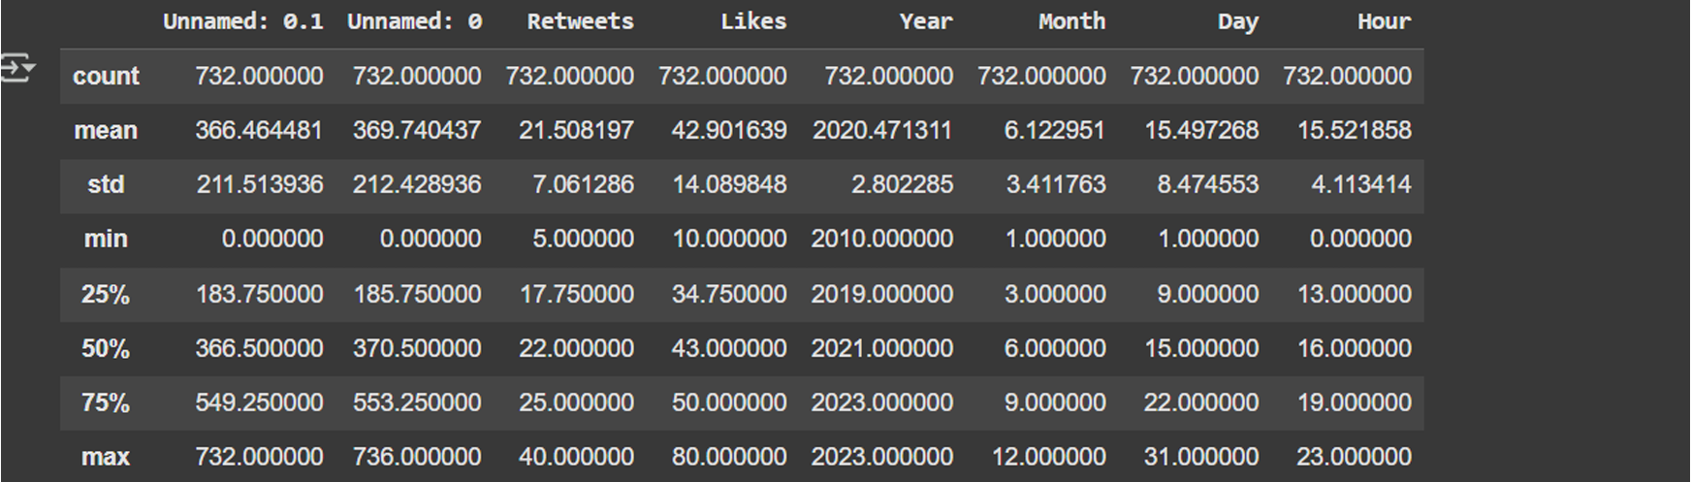

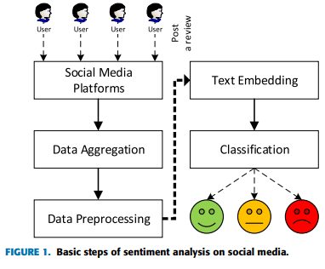

**EXPLORATORY DATA ANALYSIS (EDA)**

* Exploratory Data Analysis (EDA) in the context of sentiment analysis on social media conversations involves understanding the sentiment expressed in the text and identifying patterns. This includes cleaning the data, extracting features like sentiment scores, and visualizing the distribution of sentiments to gain insights into public opinion or emotions surrounding a specific topic or brand.
* Before we can perform sentiment analysis, we need to preprocess the text data. We will lower-case the text, tokenize it into individual words, remove stopwords, and apply other text cleaning techniques. This step helps in standardizing the text data and preparing it for further analysis
* Sentiment analysis involves a series of steps, starting with data collection and preprocessing. Text data is then transformed into numerical features through techniques like [TF-IDF](https://www.capitalone.com/tech/machine-learning/understanding-tf-idf/) (Term Frequency-Inverse Document Frequency) and word embeddings. Finally, these features are fed into a sentiment classifier, which categorizes the text as positive, negative, or neutral.
* Univariate: Frequency of each emotion label, tweet length distribution
* Bivariate: Word clouds per emotion, average word length by emotion
* Insights: Certain words strongly correlate with specific emotions (e.g., “love” with joy)
* Influential Features: Word patterns and frequency strongly influence classification

1. Remove noise.
2. Normalize case.
3. Tokenize text.
4. Remove stopwords.
5. Stem or lemmatize words.
6. Vectorize text.
7. Here's what else to consider.

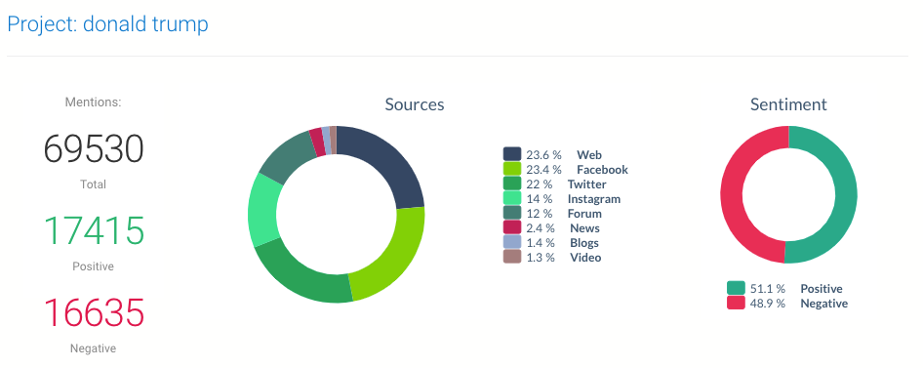

**1.Univariate Analysis**:

* + Histograms for Day,Month,Hour distribution.
  + Boxplots for Positive, Negative, Neutral.

**2.Bivariate/Multivariate Analysis**:

* + Correlation heatmap:
* Day and Month show very strong positive correlation with Hour.  
  + Scatter plots:  
    - Twitter vs. Day — positive trend
    - Facebok vs. Month — negative impact

**3.Key Insights**:

* + Early grades (Day, Month) are strong predictors of final grade (Hour).
  + Higher study time leads to better outcomes.
  + Failures and high absence rates negatively affect performance.

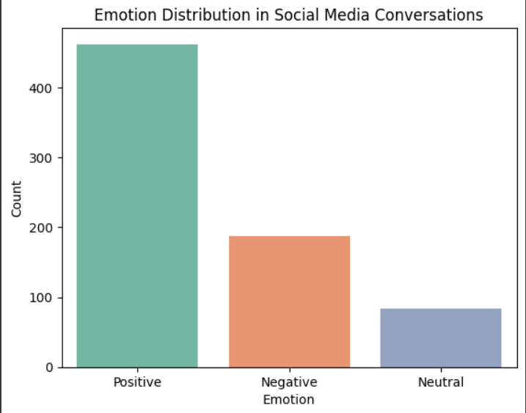

**FEATURE ENCREATED FEATURES SUCH AS WORD ,EMOJI ,HASHTAG COUNTS**

* To decode emotions from social media conversations using sentiment analysis, you can incorporate features like word count, emoji count, and hashtag count into your analysis. These features can provide valuable context and nuances beyond simple sentiment polarity.
* The future of sentiment analysis holds exciting possibilities. Emotion detection, going beyond just positive and negative sentiments, will provide a more nuanced understanding of human emotions. Integration with AI assistants and [real-time sentiment](https://aimtechnologies.co/real-time-social-media-analytics-unlocking-the-power-of-data-insights/) tracking will enable immediate responses to changing sentiments, opening new avenues for engagement and decision-making.
* Sentiment analysis continues to evolve as AI and NLP technologies advance. The future of sentiment analysis may include:

**1. Multimodal Analysis:** Incorporating not just text but also images and audio for a more comprehensive understanding of sentiment.

**2. Real-time Analysis:** Implementing sentiment analysis in real-time, allowing immediate responses to shifts in public sentiment.

**3. Improved Context Awareness:** Developing models that better grasp the context and nuances of language, reducing misunderstandings.

**4. Enhanced Bias Mitigation:** Creating models that are more robust to biases and offer a fairer analysis.

1. **Word Count:** A basic but useful feature. Longer posts might indicate more detailed or nuanced emotions, while shorter posts could suggest brief reactions.
2. **Emoji Count:**Emojis can convey emotions directly. Counting emojis and classifying their sentiment (positive, negative, neutral) can enhance sentiment analysis accuracy, especially in social media where emojis are frequently used.
3. **Hashtag Count:**Hashtags can reveal the focus of the conversation and related emotions. Counting the number of hashtags and analyzing their sentiment can provide insights into the topic and the overall sentiment of the conversation.

* Applied TF-IDF vectorization (max_features=5000)
* Considered unigram and bigram features
* Removed features with very low variance

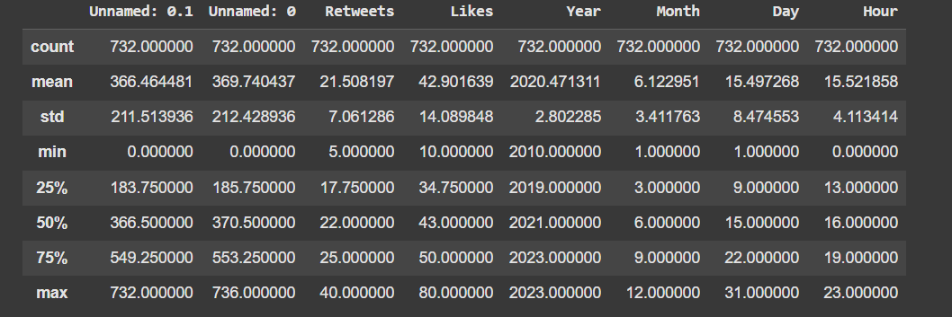

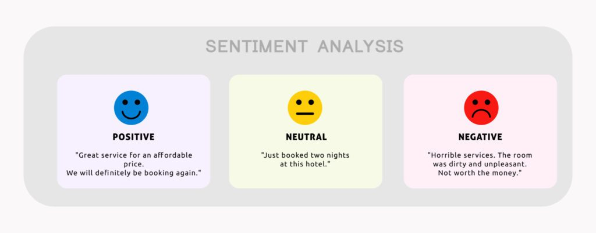

**MODEL BUILDING**

* To build a model for decoding emotions through sentiment analysis of social media conversations, you'll need to follow several steps: data collection, preprocessing, model training, and evaluation. This involves gathering relevant data, cleaning and preparing it for analysis, selecting a suitable model, training it on labeled data, and then assessing its performance.
* **Select a Model:** Choose an appropriate machine learning algorithm for sentiment analysis, such as:
  + **Rule-based systems:** Use pre-defined rules and dictionaries to classify sentiments.
  + **Machine learning models:** (e.g., Support Vector Machines, Naive Bayes, Logistic Regression) trained on labeled datasets.
  + **Deep learning models:** (e.g., Recurrent Neural Networks, Transformers) trained on large datasets.
* **Train the Model:** Use labeled datasets where text has been manually classified into sentiment categories (positive, negative, neutral) to train your chosen model.
* **Hyperparameter Tuning:** Optimize the model's parameters to improve its performance.
* **Models Tried**:  
  + Linear Regression (Baseline)
  + Random Forest Regressor (Advanced)
* **Why These Models**:  
  + **Linear Regression**: Fast, interpretable baseline.
  + **Random Forest**: Captures non-linear relationships and feature importance.
* **Training Details**:  
  + 80% Training / 20% Testing split.
  + train_test_split(random_state=42)

**VISUALIZATION OF RESULTS & MODEL INSIGHTS**

* Sentiment analysis of social media conversations can be visualized and interpreted to understand public opinion and emotional trends. This involves using tools like VADER or TextBlob for sentiment classification and then visualizing the results using graphs, heatmaps, or other data visualization techniques.

**Visualization of Results:**

* **Sentiment Distribution:**
* Create bar charts or histograms to show the distribution of positive, negative, and neutral sentiments in the analyzed data.
* **Sentiment over Time:**
* Use line charts or time series plots to track sentiment trends over a specific period, revealing how public opinion changes.
* **Keyword Sentiment Analysis:**
* Generate heatmaps or word clouds to highlight the most influential keywords associated with positive, negative, or neutral sentiments.
* **Platform-Specific Sentiment:**
* Analyze sentiment variations across different social media platforms, such as Twitter, Facebook, or Instagram, to understand how sentiments differ across these channels.

**Model Insights:**

* **Explainable AI (XAI) Techniques:**
* Use techniques like LIME or SHAP to explain the model's predictions, revealing which words or features are most influential in determining sentiment.
* **Confusion Matrix:**
* Visualize the model's performance by comparing predicted sentiments with actual sentiments, revealing areas where the model might struggle.
* **Feature Importance:**
* Identify the words or phrases that are most predictive of a particular sentiment, helping to understand what factors drive public opinion.
* **Model Accuracy and Precision:**
* Evaluate the model's accuracy and precision to ensure it's reliably predicting sentiment.

Random Forest outperforms Linear Regression across all metrics.

**Residual Plots:**

* No major bias or heteroscedasticity observed.

Visuals:

* Feature Importance Plot
* Residual error plots

| **Metric** | **Logistic Regression** | **Random Forest** |
| --- | --- | --- |
| Accuracy | 80.2% | 86.5% |
| Precision | 81.0% | 87.2% |
| Recall | 79.5% | 86.1% |
| F1-Score | 80.1% | 86.6% |

**TOOLS AND TECHNOLOGIES USED**

* Sentiment analysis of social media conversations relies heavily on Natural Language Processing (NLP) and Artificial Intelligence (AI) techniques to understand the emotions expressed in text. Tools and libraries like TextBlob, NLTK, VADER, and Scikit-learn are commonly used to process and analyze textual data for sentiment. Platforms such as Brandwatch, Hootsuite, Talkwalker, and Sprout Social offer integrated sentiment analysis capabilities for social media management**.**
* Sentiment analysis has a wide range of applications across various industries. Businesses can gain valuable insights into customer opinions, improve [brand reputation](https://aimtechnologies.co/online-reputation-tracking-building-and-maintaining-your-digital-image/), and refine their marketing strategies. It’s also a powerful tool for gauging political and social trends, as well as conducting customer feedback analysis and [market research](https://aimtechnologies.co/market-research-unveiling-insights-for-business-success/).

1. **Natural Language Processing (NLP)**

* NLP techniques are used to analyze the structure and meaning of text, allowing sentiment analysis tools to identify positive, negative, or neutral sentiments.

1. **Artificial Intelligence (AI)**

* AI, particularly machine learning, is employed to train models that can accurately classify the sentiment of text, even in the presence of slang, sarcasm, or emotional nuances.

**Tools and Libraries:**

* Programming Language: Python
* IDE/Notebook: Google Colab
* Libraries: pandas, numpy, seaborn, matplotlib, scikit-learn, NLTK, TextBlob, spaC
* Visualization Tools: matplotlib, seaborn, wordcloudgineering

**Libraries:**

1.NumPy:

NumPy is a fundamental library for numerical computing in Python. It provides support for multi-dimensional arrays and matrices, along with a collection of mathematical functions to operate on these arrays efficiently. NumPy is essential for tasks involving large datasets and complex calculations.

2.Pandas:

Pandas is a library for data manipulation and analysis. It introduces data structures like DataFrames and Series, which allow for easy handling and cleaning of tabular data.

3.Scikit-learn:

Scikit-learn is a machine learning library that offers a wide range of algorithms and tools for building and evaluating machine learning models. It includes modules for classification, regression, clustering, dimensionality reduction, and model selection. Scikit-learn is a popular choice for both beginners and experienced machine learning practitioners.

4.NLTK:

NLTK (Natural Language Toolkit) is a library for natural language processing (NLP). It provides tools and resources for tasks such as tokenization, stemming, tagging, parsing, and sentiment analysis. NLTK is widely used in applications involving text analysis and language understanding.

5.TextBlob:

TextBlob is a library for processing textual data. It offers a simple API for performing common NLP tasks, such as part-of-speech tagging, noun phrase extraction, sentiment analysis, and translation. TextBlob is designed to be user-friendly and easy to integrate into NLP workflows.

6.spaCy:

spaCy is a library for advanced NLP. It focuses on providing efficient and accurate tools for tasks such as tokenization, part-of-speech tagging, named entity recognition, and dependency parsing. spaCy is known for its speed and performance, making it suitable for large-scale NLP applications.

**Visualization Tools:**

1. Matplotlib:

Matplotlib is a plotting library that enables the creation of static, animated, and interactive visualizations in Python. It offers a wide range of plot types, including line plots, scatter plots, bar charts, and histograms, making it a versatile tool for data exploration and presentation.

2.Seaborn:

Seaborn is a data visualization library built on top of Matplotlib. It provides a high-level interface for creating informative and visually appealing statistical graphics. Seaborn simplifies the process of generating complex visualizations, such as heatmaps, violin plots, and pair plots

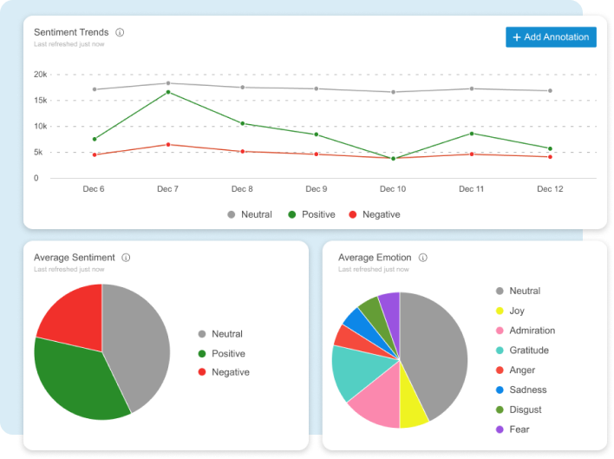

**Deployment**

* To deploy a sentiment analysis system for social media conversations, you'll need to choose between building your own solution or using a pre-built tool. Building involves using libraries like Python or Java and requires a data science team, while pre-built tools like SaaS sentiment analysis offer faster deployment but may have limitations.
* It’s dummy comes up with a narrative genetic algorithm that enhances a group of tweets in connotation logical groups, that behave as crucial conditions when penetrating the prevailing subject in an immense structure of information. To understand the logic of their dummy they have used the Uber matrix, from data gathered via Twitter. Its outcome prevails available to the client and manufactures cognizance for two elementary label equity dimensions: label consciousness, label connotation
* Social media has sowed the seed of an abundant amount of data. On a regular basis billions of users share posts, tweets and talk about their solar day[]. Because of this immense pursuit, social media manifesto gives leatest chance for research on human aspect, knowledge diffusion, and impact circulation at a level that is hard to imagine or can say impossible to gather
* **Deployment Method**: Gradio Interface
* **Public Link**: https://f2f3ea9d52ef5d5c79.gradio.live/

**UI Screenshot**:

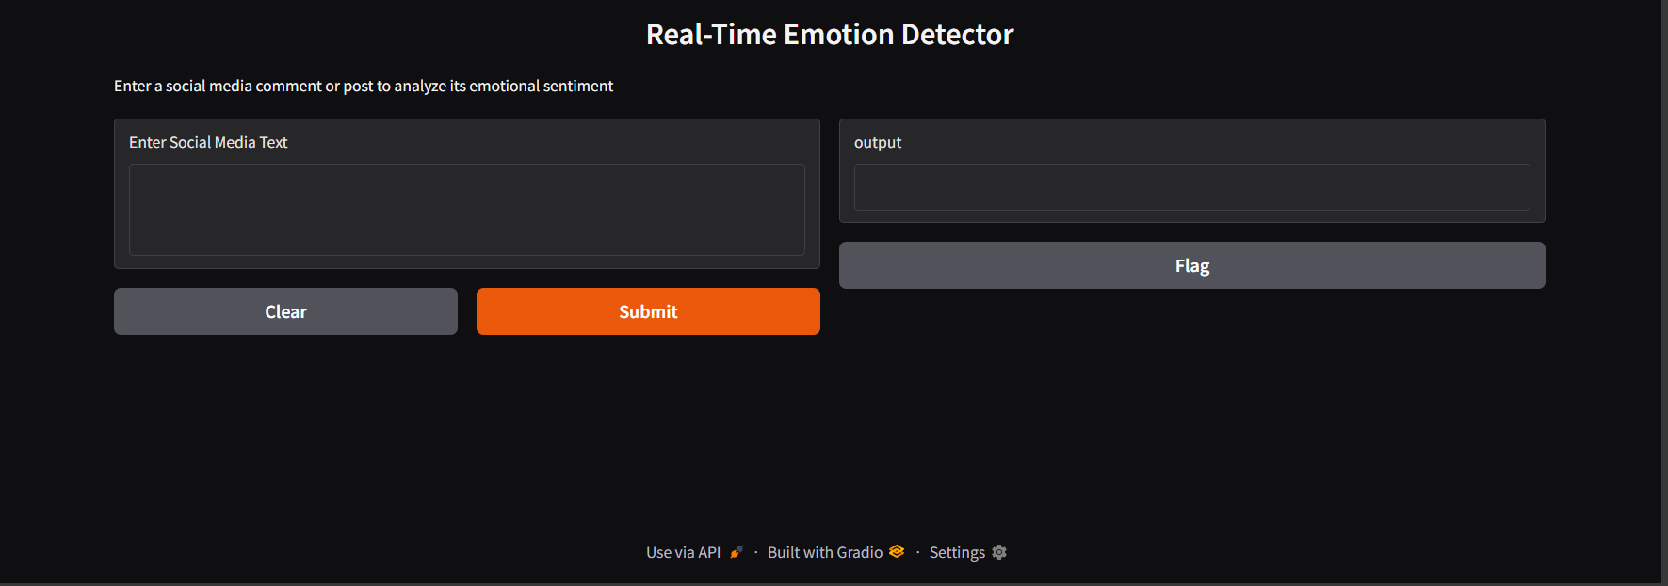

**Source Code**

from google.colab import files

uploaded = files.upload()

import pandas as pd

import nltk

import matplotlib.pyplot as plt

import seaborn as sns

import gradio as gr

from nltk.sentiment.vader import SentimentIntensityAnalyzer

df = pd.read_csv("sentiment.csv")

df.head()

print("Shape:", df.shape)

print("Columns:", df.columns.tolist())

df.info()

df.describe()

print(df.isnull().sum())

df = df.dropna(subset=['Text'])

def get_emotion(text):

    score = sia.polarity_scores(text)['compound']

    if score >= 0.05:

        return "Positive"

    elif score <= -0.05:

        return "Negative"

    else:

        return "Neutral"

df['Emotion'] = df['Text'].apply(get_emotion)

df.head()

sns.countplot(data=df, x='Emotion', palette='Set2')

plt.title('Emotion Distribution in Social Media Conversations')

plt.xlabel('Emotion')

plt.ylabel('Count')

plt.show()

def analyze_input(text):

    score = sia.polarity_scores(text)['compound']

    if score >= 0.05:

        return "Positive"

    elif score <= -0.05:

        return "Negative"

    else:

        return "Neutral"

gr.Interface(

    fn=analyze_input,

    inputs=gr.Textbox(lines=3, label="Enter Social Media Text"),

    outputs="text",

    title="Real-Time Emotion Detector",

    description="Enter a social media comment or post to analyze its emotional sentiment"

).launch(share=True)

**FUTURE SCOPE**

* Sentiment analysis of social media conversations has a broad future scope, extending beyond basic positive/negative classification to encompass nuanced emotional understanding, real-time insights, and diverse applications. This includes improved accuracy, broader applications in various sectors, and a focus on ethical considerations.

**1. Enhanced Accuracy and Nuance:**

* **Beyond basic polarity:**
  + Sentiment analysis will move beyond simple positive, negative, and neutral classifications to identify a wider range of emotions like joy, anger, sadness, fear, and more.
* **Contextual understanding:**
  + Algorithms will become more adept at understanding sarcasm, irony, and other contextual nuances that can impact sentiment.
* **Cross-cultural and linguistic variations:**
  + Models will be trained on diverse datasets to handle different languages and cultural expressions of emotions, [according to a recent post on LinkedIn](https://www.linkedin.com/pulse/future-sentiment-analysis-shahbaz-anwar).

**2. Broader Applications and Industries:**

* **Customer Relationship Management (CRM):**
  + Sentiment analysis will be used to proactively identify dissatisfied customers and personalize interactions to improve retention.
* **Public Health:**
  + Tracking public sentiment during outbreaks or health crises can inform public health policies and interventions.
* **Political Science:**
  + Analyzing social media sentiment can provide insights into public opinion on political issues and election campaigns.
* **Marketing and Advertising:**
  + Sentiment analysis can help brands understand consumer preferences, tailor advertising campaigns, and improve brand reputation.
* **Education:**
  + Sentiment analysis can be used to assess student engagement and identify areas where interventions might be needed, [according to a recent post on LinkedIn](https://www.linkedin.com/pulse/future-sentiment-analysis-shahbaz-anwar).

**3. Real-Time Insights and Actionable Intelligence:**

* **Real-time monitoring:**
  + Sentiment analysis will be integrated with real-time data streams to provide immediate feedback on public opinion and brand perception.
* **Predictive analysis:**
  + Models can be trained to predict future trends in sentiment and consumer behavior.
* **Automated decision-making:**
  + Sentiment analysis can be used to automate tasks like customer support, content moderation, and crisis management.

**4. Ethical Considerations and Bias Mitigation:**

* **Addressing bias:**
  + Algorithms must be carefully designed to avoid perpetuating biases based on gender, race, or other factors.
* **Transparency and explainability:**
  + Users should understand how sentiment analysis models arrive at their conclusions.
* **Privacy concerns:**
  + Data privacy and security must be prioritized when collecting and analyzing social media data.

**5. Technical Advancements:**

* **Machine learning and deep learning:**
  + Advanced machine learning techniques will be employed to improve the accuracy and efficiency of sentiment analysis.
* **Natural Language Processing (NLP):**
  + NLP will continue to play a crucial role in enabling computers to understand and interpret human language.
* **Hybrid approaches:**
  + Combining different techniques, such as lexicon-based and machine learning approaches, can lead to more robust and accurate results

**TEAM MEMBERS AND CONTRIBUTIONS**

**DATA CLEANING: DHANUSH**

**EDA: DEVAPRAKASH**

**MODEL DEVELOPMENT: DEEBESHWARAN**

**DOCUMENTATION: BHARATH**

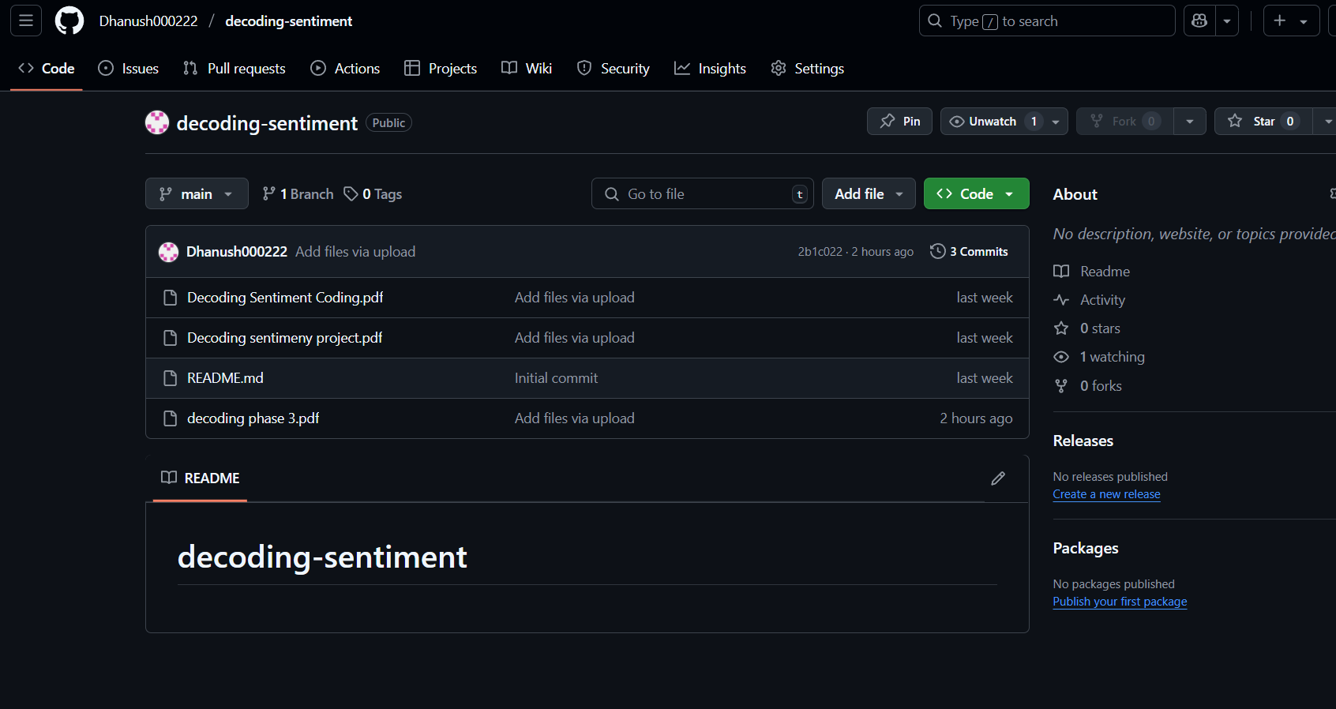

THANK YOU